Challenge:

Computational Recruiting

# Challenge Description :

**Not too long ago, your cyborg detective friend John Love told you he heard some strange rumours from some folks in the Establishment that he's searching into. They talked about the possible discovery of a new vault, vault 79, which might hold a big reserve of gold. Hearing of these news, youband your fellow compatriots slowly realized that with that gold reserver you could accomplish your dreams of reviving the currency of old times, and help modern civilization flourish once more. Looking at the potential location of the vault however, you begin to understand that this will be no easy task. Your team by itself is not enough. You will need some new recruitments. Now, standing in the center of Gigatron, talking and inspiring potential recruits, you have collected a big list of candidates based on skills you believe are needed for this quest. How can you decide however which ones are truly worthy of joining you?**

# Context :

* **Using the Data given, figure out the best 14 candidates out of the 200 given, when you have achieved all 14, connect to the Server to input the candidates and get the flag.**
* **The formula to calculate the best 14 candidates goes as**

**Overall value = Round ( 5× (( health × 0.18 ) + ( agility × 0.20 )+ ( charisma × 0.21 ) +**

**( knowledge × 0.08 ) + ( energy × 0.17 ) + ( resourcefulness × 0.16 )))**

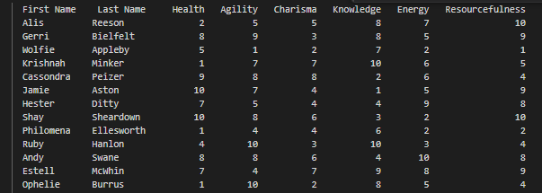

# Flag :

* **When going through the data I tried to think of a way I could process it all to get the best 14 candidates out of the bunch, without manually going through them all.**
* **The best way I could do this would be to run it through a python script with the formula to extract the best candidates.**
* **The script will be on my github as the code is to big to copy and paste [**[**Script**](https://github.com/Birdo1221/HTB-writeup/blob/main/Computational%20Recruiting.py)**] i will upload a pic of the logic :**

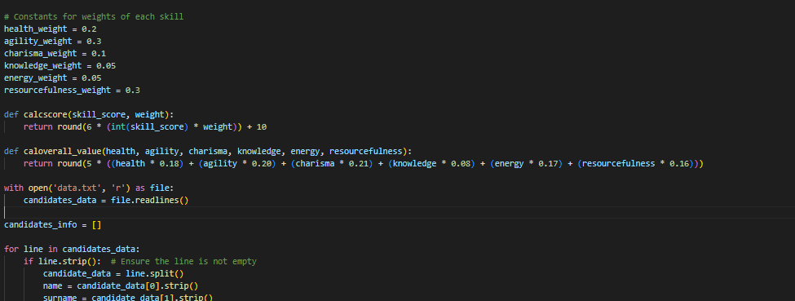

* **Running the code gave me 14 candidates, connecting to the server and inputting the results from the python script gave me a Positive result ending in the Flag being given.**



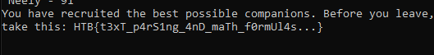

* **The Flag given to us is : HTB{t3xT_p4rS1ng_4nD_maTh_f0rmUl4s...}**